Sum of Elements in dart
Exercise #3
Flutter Developer Bootcamp

Purpose
This Exercise demonstrates how to use Dart's List class and its methods to generate a list of integers and then calculate the sum of those integers using the reduce method

Problem
In the provided Exercise You need to create as follows:

This Exercise generates a list of integers from 1 to 10, calculates their sum, and prints both the list and the sum.

How to Solve
1. Checkout the Exercise from Git Repo:
git clone -b <user-branch> <repo-URL>
2. Open the root folder inside VS Code
3. Open the root folder in terminal
4. Run the command dart run filename.dart
5. List Generation:Initialize a list called numbers. It generates a list containing integers from 1 to 10 using the List.generate method. The List.generate method takes two arguments: the length of the list (which is 10 in this case) and a function that generates each element. The function (index) => index + 1 generates numbers starting from 1 and increments by 1 for each subsequent element.
6. Sum Calculation:Calculates the sum of all elements in the numbers list using the reduce method. The reduce method takes a binary function as an argument, which combines two elements at a time. In this case, the lambda function (value, element) => value + element adds each element to the accumulator value, starting from the first element. The result is stored in the variable sum.
7. Printing Results:Print the generated list of numbers and the sum of all elements to the console. The $numbers and $sum are placeholders that get replaced by the actual values of the numbers list and sum variable, respectively.
8. Go To File: <specific-file-with-Sum-method> à <method-name>, implement your logic.

You will Achieve
When you complete this Exercise you will learn the following:
- List Generation: The List.generate function is used to create a list of integers from 1 to 10.

- Sum Calculation: The reduce method is applied to calculate the sum of all elements in the list.

- Printing Results: The print function is used to display both the generated list and the sum of its elements.

Screenshots

Expected output (with Sum of Elements)

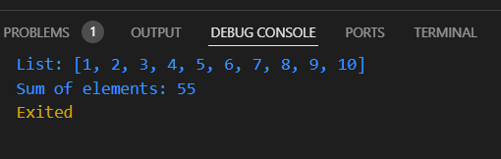

How to submit your Exercise
Push your project back to the same git branch using command:
<command name>

Happy Coding!

